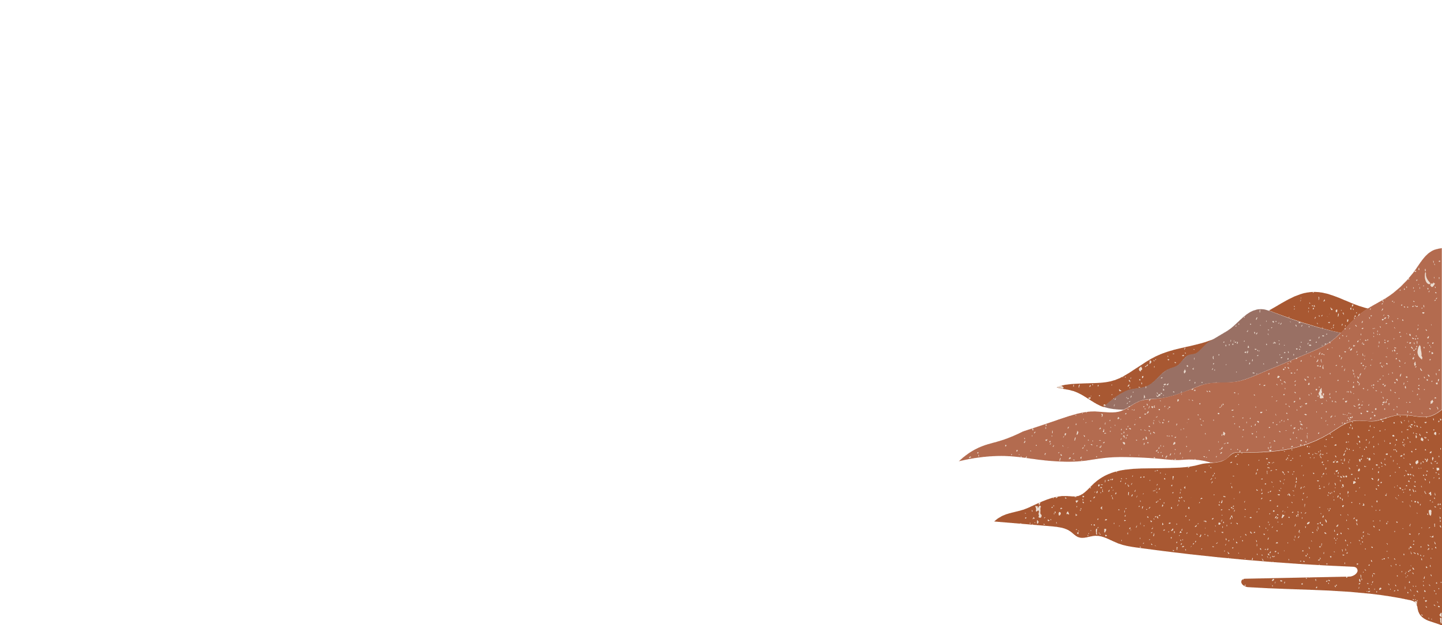

YOUR LOGO
Northwind Traders
234 5th Ave.
Madison, WI 54321
Terje Möttölä
987 6th Ave.
Santa Fe, NM 12345

